Curriculum Vitae

Mahida Yuvrajsinh J.
D

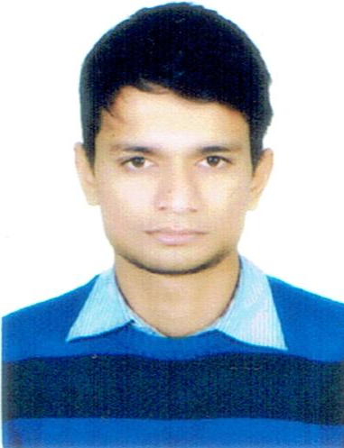
3-6, Rajput Faliyu,
Village: Sava,
Taluka : Mangrol
Dist : Surat 394125
Guj. INDIA
Mob. : +91 97240 56001
Email : yuvrajsinhmahida2192@gmail.com
Objective

Seeking a challenging position according to my technician skills and knowledge to the best of my ability where I can utilize my sound technical knowledge and skills as well as which allows me to learn new technologies while utilizing my experience so that I can keep up to date the organization with future advance technology and contribute to the growth of the organization.

School Records

Examination | Board | Passing Year | Percentages | Class
S.S.C. | G.S.E.B. | March 2007 | 48.00% | Pass Class

Technical Records

Examination | Board | Passing Year | Percentages | Class
Diploma in Electrical Engg. | T.E.B. Gandhinagar | 2012 | 42.11% | Pass Class
Supervisor Certificate | Date of Issue : 21/06/2013, Place of Issue : Surat  Permit No. G/GS-E-001901-DEE-2013

Computer Skills

- CCC
- AutoCAD 2D
Apprenticeship Training

- Organisation Name : Piramal Glass
- Duration : 10 days (From 07th July, 2009 to 17th July, 2009)
- Status : Completed
- Designation : Industrial Training

Work Experience
Name of Organisation | Designation | Duration | Salary CTC
Shree Ganesh Khand Udyog Sahakari Mandali Ltd. Ankleswar. | Ele. Supervisor | April 2013 to March 2014 | 48,000 /-
Tradelink Pvt. Ltd.  Saiyedpura, Surat ( | Site Supervisor | May 2014 to Feb 2015 | 1,08,000 /-
Goldi Green Technologies Pvt. Ltd.  Pipodara, kim | Supervisor | Dec 2015 to May 2016 | 1,08,000 /-
Shree Ganesh Khand Udyog Sahakari Mandali Ltd. Ankleswar. | Ele. Supervisor | July 2016 to  Running... | 1,02,000 /-

Personal Details

Full Name | Mahida Yuvrajsinh Jashwantsinh
Date of Birth | 30th May, 1992
Nationality | Indian
Caste | Hindu -Rajput
Marital Status | Bachelor
Gender | Male
Language Known | Gujarati, Hindi & English
Hobbies | Reading, Sports & Travelling

Declaration

I assure you that above stated information are true to best my knowledge and work in your organisation with sincerity and honestly.
Thanking you.

Date : ------------------------------------
Place : (Mahida Yuvrajsinh J.)

